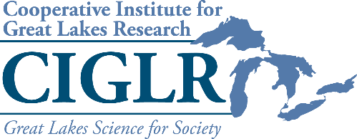
2020 ECO Program Support
Request for Proposals

CIGLR is offering awards of up to $2,000 to support undergraduate, graduate, or comparable research assistants who incorporate a political engagement, communications, or outreach component into their work. The ECO program component must highlight the contributions of NOAA, CIGLR, and CIGLR’s Regional Consortium Partners to research and management of the Great Lakes for the good of its people. Examples include, but are not limited to, Congressional visits, op-ed articles, K‐12 education activities, community outreach events, public education talks, establishment of social media sites or feeds, factsheets, newsletters, or magazines. For information about CIGLR’s ECO Program, visit ciglr.seas.umich.edu/outreach-education/eco-program/.
Any principal investigator or student affiliated with a CIGLR Regional Consortium University Partner institution or Private Sector Partner organization may request ECO funds. ECO funding requests should include the following (1 page max):
- A brief summary of the project.
- The proposed ECO program component, including the target audience and how it will highlight NOAA, CIGLR, and Regional Consortium partner contributions to research and management of the Great Lakes.
- A brief description of how funds will be used.
- The impact measures of the proposed activity (e.g., number of social media followers and impressions, number of letters sent, number of factsheets produced, number of attendees at outreach event).
ECO funding recipients are required to submit a final report to CIGLR within 60 days of the completion of the ECO activity, including the proposed impact measures.
Proposals will be reviewed by CIGLR Program Manager and judged on the: 1) potential reach of the proposed activities, 2) degree to which the proposed activities relate to and highlight NOAA in the Great Lakes, and 3) potential lasting impact of the proposed activities (e.g., new social media accounts or websites, lesson plans, etc.).
ECO program support can be requested at any time. Proposals should be submitted to Mary Ogdahl (ogdahlm@umich.edu).

