Budget narrative (also included in Project Narrative, pg. 76)

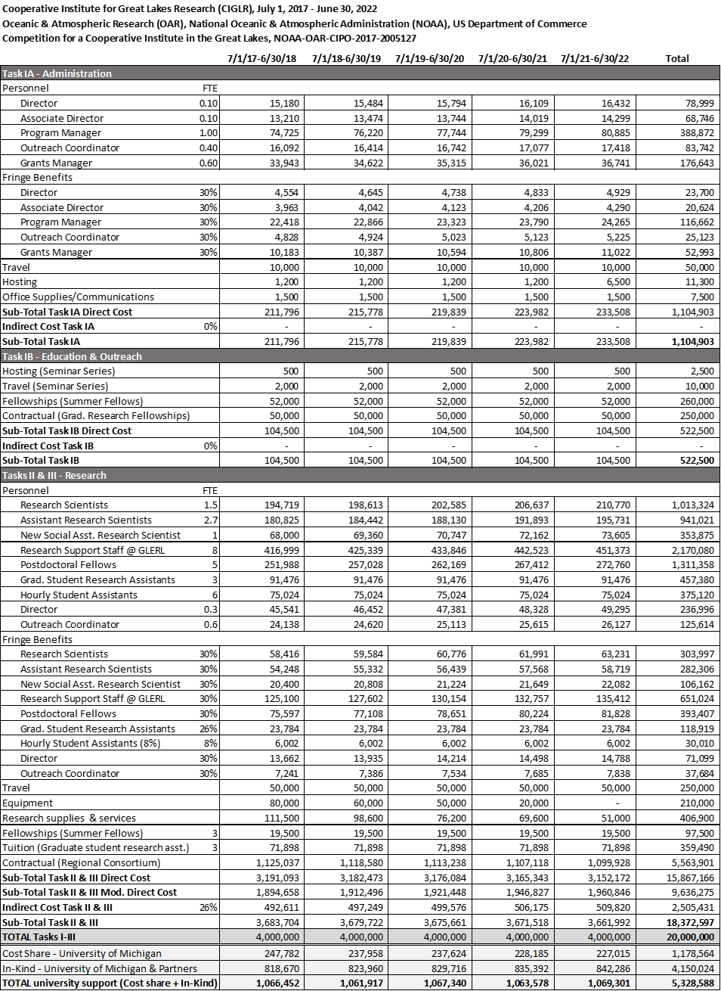

Budget Justification
The requested budget partially supports the administrative, programmatic, and research activities described in this proposal. Additional support for the proposed activities will come from the University of Michigan Cost Share and in-kind support from both the University of Michigan and the Regional Consortium. Budget requests are described below by task, including Task IA administrative costs, Task IB education and outreach programmatic costs, and combined Tasks II and III research costs. While these budgets provide cost estimates for supporting CIGLR activities, we acknowledge that actual Task IB, II, and III budgets will be based on submission and NOAA approval of separate annual project proposals, awarded as amendments to the parent Cooperative Agreement. Accordingly, we also acknowledge that the annual Task IA budget will be determined as a percentage of Task II and III funding, established annually by the CI Program Office.

Task I. Task I activities are related to the overall management of the CI and to overall education and outreach activities not linked to specific research projects. Task I activities are divided into two categories: Task IA – Administration and Task IB – Education and Outreach.

Task IA - Administration $1,104,903
Task IA funds in the amount of $1,104,903 are requested to support salary and fringe benefits for CIGLR administrative staff and CIGLR operational costs.

- Salary $797,002
Funds ($78,999) are requested to provide the Director with 10% support per year, to oversee the administration and budget of CIGLR, develop and maintain CIGLR’s programmatic activities, build research and development, mentor CIGLR’s Research Scientists and postdocs, and serve as CIGLR’s primary spokesperson. Funds ($68,746) are requested to provide the Associate Director with 10% support per year to co-manage CIGLR’s research activities, update the Director on research activities and budgets, foster partnerships between Regional Consortium members and CIGLR and GLERL scientists, lead CIGLR’s career training activities, and serve as spokesperson for CIGLR on the Director’s behalf. Funds ($388,872) are requested to provide 100% support per year to the Program Manager, for leading the development and implementation of the Engagement, Career Training, and Outreach & Communications (ECO) Program, creating and maintaining budget projections, managing CIGLR personnel, overseeing research proposal development, and leading the preparation of CIGLR’s annual Performance Progress Report. Funds ($83,742) are requested to provide the Communications and Outreach Specialist with 40% support per year, to manage and maintain the CIGLR website, lead the preparation of quarterly and annual newsletters, engage in community outreach activities, manage CIGLR social media accounts, and maintain a database of CIGLR’s products and performance tracking metrics. Funds ($176,643) are requested to provide 60% support per year to the Grants and Contracts Specialist, to process all Cooperative Agreement and external grant proposal submissions, perform post-award grant management, establish and monitor sub-awards, process invoices, prepare quarterly budget reports, and ensure compliance with University of Michigan financial policies and procedures.

- Fringe Benefits $239,101
Fringe benefit rates for permanent University of Michigan employees are based on actual costs and vary depending on the coverage selected by the employee. An average fringe benefit percentage of 30% was applied for Task IA administrative staff.

- Travel – Domestic $50,000
Travel support is requested for (1) the Director and Program Manager to travel to NOAA Headquarters in Silver Spring, Maryland for the annual CI Directors’ Meeting, (2) the Program Manager to attend the annual CI Administrators’ Meeting (various locations), and (3) collaborative research planning meetings between the Director and Regional Consortium principal investigators.

- CI Directors’ Meeting (Silver Spring, MD)
Estimated cost: $3,500/year x 5 years = $17,500

- CI Administrators’ Meeting (Various CI locations)
Estimated cost: $1,000/year x 5 years = $5,000

- Collaborative research planning meetings (Various)
Estimated cost = $5,500/year x 5 years = $27,500

- Hosting $11,300
Funds are requested to provide hosting support for CIGLR advisory board meetings and the CIGLR 5-year review. Hosting funds will be used for 1 Executive Board meeting per year and 2 Council of Fellows meetings per year, in addition to the NOAA Science Advisory Board review during year 5.

- Supplies & Communications $7,500
Funds are requested to purchase general office supplies such as printer paper, notebooks, envelopes, writing utensils, etc., for the CIGLR administrative office at the University of Michigan. Estimated office supply costs are $1,275 per year. Funds are also requested for communications service for office phones and a fax machine, estimated at $225 per year. The total estimated office supplies and communications cost per year is $1,500.

- Task IA Total Direct Cost $1,104,903

- Task IA Indirect Cost $0
The University of Michigan will waive indirect costs on Task IA funds.

- Task IA Total Cost $1,104,903

Task IB – Education and Outreach $522,500
Task IB funds in the amount of $522,500 are requested to support a portion of CIGLR’s Engagement, Career Training, and Outreach and Communications (ECO) Program activities. Specific programs to be supported are the Summer Fellowship program, Seminar Series (University of Michigan co-sponsor), and the Graduate Research Fellowship program. The rest of the ECO Program activities are supported by the University of Michigan Cost Share (see below).

- Summer Student Fellowship Program $260,000
Funds are requested to support the Great Lakes Summer Fellowship program. CIGLR will provide summer fellowships to 8 undergraduates and graduate students per year. Each student fellow will receive a $6,500 stipend.

8 fellowships per year x $6,500 stipend x 5 years = $260,000

- Seminar Series $12,500
Funds are requested to partially support the Great Lakes Seminar Series, which comprises 12 total invited seminars per year. The requested funds will be used for hosting expenses for 6 seminars and travel expenses for 2 speakers. This program is cost-shared with the University of Michigan (see Cost Share section).

Hosting: 6 seminars per year x $83 per seminar x 5 years = $2,500
Travel: 2 speakers per year x $1,000 per speaker x 5 years = $10,000

- Graduate Research Fellowships (Sub-awards) $250,000
Funds are requested to support 2 Great Lakes Graduate Research Fellowships per year. Graduate Research Fellowships will be $25,000 each and competitively sub-awarded to University Partner principal investigators within the Regional Consortium to support graduate students at their institutions.

Fellowship sub-awards: 2 fellowships per year x $25,000 per fellowship x 5 years = $250,000

- Task IB Direct Cost $522,500

- Task IB Indirect Cost $0
The University of Michigan will waive indirect costs on Task IB funds.

- Task IB Total Cost $522,500

Tasks II & III. Tasks II and III budgets include costs related to CI research activities, including salary, fringe benefits, travel, equipment, supplies, and sub-awards. Task II research involves ongoing collaboration with NOAA scientists, typically fostered by the collocation of CI and NOAA employees. Task III research activities are related to the NOAA and CI mission, but do not involve direct collaboration with NOAA scientists. Task III activities may include research funded by other NOAA competitive grant programs. Although we anticipate that CIGLR research will primarily be Task II activity, we cannot predict the division of Task II and III research and thus present these budgets together.

- Salary $6,984,767
Funds are requested for salary support of CIGLR Research Institute faculty, staff, postdocs, and students employed by the University of Michigan and collocated with NOAA-GLERL. Research Scientists and Assistant Research Scientists (1.48 FTE, $1,013,234 and 2.7 FTE, $941,021, respectively) will serve as principal investigators on Cooperative Agreement and external proposals, engage in collaborative research with NOAA scientists and Regional Consortium partners, and mentor undergraduates, graduate students, and postdoctoral fellows. Upon formation of the new CIGLR, the School of Natural Resources and Environment has pledged to hire a new Social Assistant Research Scientist (1 FTE; $353,875) who will launch a social science research program at GLERL to study the Great Lakes as a coupled human-natural system. Research support staff (8 FTE; $2,170,080) will work with CIGLR and GLERL principal investigators on technical aspects of their research projects. Postdoctoral fellows (5 FTE; $1,311,358) will work with CIGLR and GLERL Research Scientists to receive early career training in a NOAA mission-related research topic in the Great Lakes. All Research Institute faculty, staff, and postdocs will produce high-quality research outcomes, such as peer-reviewed publications, technical reports, and presentations at scientific seminars and conferences. Graduate Student Research Assistants (3 per year; $457,380) will work with a CIGLR or GLERL principal investigator to complete a graduate research assistantship, which may include thesis or dissertation research. Hourly Student Assistants (1,042 hours/year x 6 students; $375,120) will provide CIGLR and GLERL principal investigators with technical research support. As CIGLR’s chief science advisor, the Director (0.3 FTE; $236,996) will devote time to each research project to guide the formation of objectives, review the quality of research, and ensure the creation of products that have broad societal impact. The Outreach Coordinator (0.6 FTE; $125,614) will be integrated into each research project and be responsible for communicating project-specific research outcomes and supporting outreach activities for all CIGLR research projects.

- Fringe Benefits $1,994,608
Fringe benefit rates for permanent University of Michigan employees are based on actual costs and vary depending on the coverage selected by the employee. An average fringe benefit percentage of 30% was applied to all permanent Task II research staff. Fringe benefits for Graduate Student Research Assistants are 26%. Fringe benefit rates for hourly University of Michigan employees are calculated at a rate of 8% of salary to cover FICA costs.

- Travel – Domestic $250,000
Funds are requested to support research project-related travel, including field work, scientific conferences, workshops, trainings, and meetings. Travel funds will be used by CIGLR Research Scientists, staff, and students. The estimated travel cost per year is $50,000.

- Equipment $210,000
Funds are requested to purchase lab and field equipment needed to execute CIGLR research projects. Specific pieces of equipment to be purchased will be identified and proposed during the annual research planning process. The estimates and distribution of equipment costs were based on the historical equipment expenses for CILER over the past 5 years.

- Research Supplies and Services $406,900
Funds are requested to purchase field and laboratory supplies needed to execute CIGLR research projects. These funds will also be used for communications services related to operating CIGLR observing systems. The estimates and distribution of supply and services costs were based on the historical expenses for CILER over the past 5 years.

- Fellowships $97,500
Funds are requested to support summer student fellowships (3 per year; $97,500) to work with CIGLR and GLERL principal investigators on components of CIGLR research projects.

- Tuition $359,490
Funds are requested to support full-time tuition waivers for Graduate Student Research Assistants (3 per year; $359,490) as part of their research assistant package to work with CIGLR and GLERL principal investigators.

- Regional Consortium Research (Sub-awards) $5,563,901
Funds are requested to support cooperative research by members of the CIGLR Regional Consortium. CIGLR will issue Task II and III sub-awards to Regional Consortium principal investigators equivalent to approximately 31% of the total Task II and III research funds. An additional 7% will be awarded to Regional Consortium members through Cost Share funds (described below). The University of Michigan will waive indirect charges on sub-awards to University Partners and charge 26% on the first $25,000 for all other sub-awards to other institutions. Indirect costs for sub-awards to University of Michigan principal investigators outside of the Research Institute will be charged at the off-campus rate of 26%.

- Task II and III Direct Cost $15,867,166

- Task II and III Modified Total Direct Cost $9,636,275
The University of Michigan will not charge indirect costs on equipment, fellowships, tuition, sub-awards to University Partners, or other sub-awards over $25,000.

- Task II and III Indirect Cost $2,505,431
An indirect cost rate of 26% will be charged on Task II Modified Total Direct Costs. This rate is equivalent to the University of Michigan off-campus rate and the rate previously established between the University of Michigan and NOAA for CILER research.

- Task II and III Total Cost $18,372,597

Cost Share by Host $1,178,564
The University of Michigan has committed to partner with NOAA by cost sharing CIGLR Task IB programs in the amount of $1,178,564. Annual cost share contributions will come from the University of Michigan’s Office of Research, the School of Natural Resources and Environment (SNRE), the School of Engineering, the School of Literature, Sciences, and the Arts (LSA) Department of Ecology and Evolutionary Biology (EEB), and the LSA Department of Earth and Environmental Sciences (EES).

Cost Share funds will be primarily used to support CIGLR Task IB programs that connect CIGLR and GLERL researchers with Regional Consortium University Partners. These programs include Postdoctoral Fellowships (2 per year), Summits and Working Groups (3-5 per year), Rapid Grant funding (3 per year), and Education and Outreach programs at Consortium institutions. The total Cost Share funds sub-awarded to Regional Consortium University Partners is expected to be equivalent to approximately 7% of the total Task II/III funding. Cost Share funds will also be used to match NOAA Task IB support of the Great Lakes Seminar Series (6 seminars hosting; 2 seminars travel).

In-Kind Support $4,150,024
The University of Michigan and Regional Consortium institutions have committed to contribute to the NOAA partnership through in-kind support in the amount of $4,150,024.

Host $1,350,362
As host of the CI, the University of Michigan SNRE will provide CIGLR with an administrative office suite and administrative support staff (human resources, finance) at no charge. SNRE also provides 10% of Research Scientist and Assistant Research Salaries for administration, an IDC waiver on all sub-awards to Regional Consortium University Partners, and an IDC waiver on Task IA funds. All Task II funding to University of Michigan principal investigators outside of CIGLR is subject to a reduced IDC rate (26% off-campus rate).

Regional Consortium $2,799,662
In their Memoranda of Understanding (Appendix 4) with CIGLR, Regional Consortium University Partners agreed to reduced indirect cost rates of 26% for all NOAA projects sub-awarded through CIGLR, reduced indirect costs of 10% on postdoctoral and graduate fellowships funded through CIGLR’s programmatic activities, and full access by NOAA scientists, CI scientists, and other University Partner scientists to Great Lakes to research vessels and laboratory facilities at an “in-house” cost. University Partners will also match postdoctoral fellowships (~$72,000 each) sub-awarded to their institution through CIGLR. The University of Windsor has pledged to use $25,000 Canadian (~$19,000) per year to benefit CIGLR programs and enhance connections with GLERL.

The total university contribution to NOAA research in the Great Lakes through CIGLR is $5,328,588.

