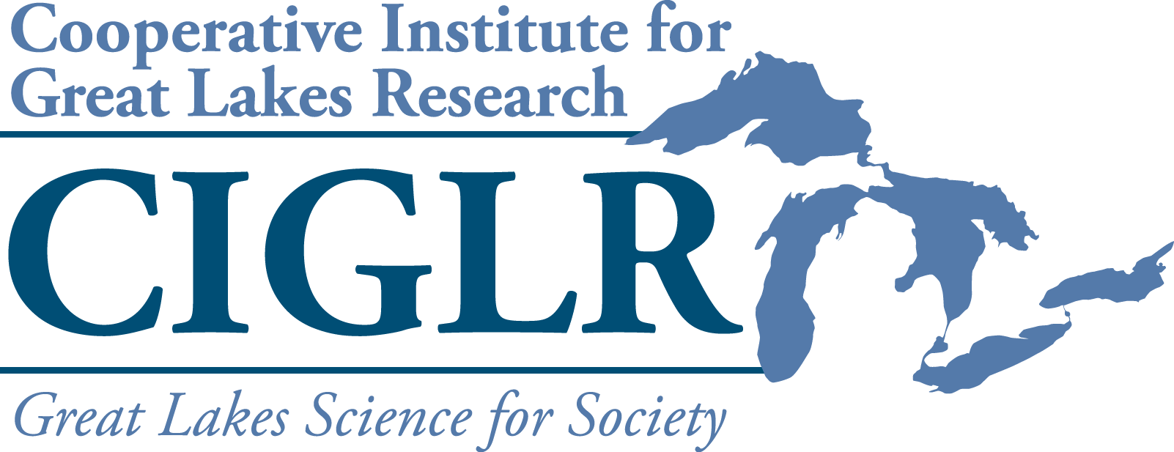
2022 Graduate Research Fellowships
Request for Proposals

Description: The Cooperative Institute for Great Lakes Research (CIGLR) is soliciting proposals from Regional Consortium University Partners for two (2) Graduate Research Fellowships sponsored by NOAA’s Great Lakes Environmental Research Lab (GLERL). The goals of these fellowships are: 1) to provide training and educational opportunities for students who will become the next generation of Great Lakes researchers, 2) enhance collaborations between CIGLR’s University Partners and PIs at NOAA GLERL, and 3) increase student retention within the freshwater aquatic sciences. We also seek to use these fellowships to increase diversity in STEM disciplines (science, technology, engineering and math), and thus, strongly encourage proposals that support students from groups which have been traditionally underrepresented in government and academic workforces.

Funding: Research fellowships will provide graduate students (MS or PhD) with $25,000 of funding for 12 months. These funds can be used for student salary, tuition, supplies and travel. Priority will be given to projects that foster interaction within the CIGLR Regional Consortium. See https://ciglr.seas.umich.edu/organization/ for more information.

Eligibility. Graduate Research Fellowships may be used to support any graduate student working with a tenure-track faculty member from a CIGLR University Partner institution. Proposals may be submitted by either the graduate student or faculty member. Prior fellowship awardees are eligible to re-apply.

Requirements:
- Graduate Research Fellowships require direct involvement with both a university lead mentor and a NOAA Great Lakes Environmental Research Laboratory (GLERL) or CIGLR Research Institute co-mentor.
- If COVID-19 restrictions on in-person work are lifted at NOAA GLERL, there are two possible models for co-mentorship:

  - The student spends the 9-mo. academic year at a CIGLR University Partner institution with a three‐month summer component at a NOAA facility, either GLERL in Ann Arbor, MI, or the Lake Michigan Field Station in Muskegon, MI. This model requires split mentoring roles, with an on-site university scientist as the lead mentor, and a NOAA GLERL or CIGLR Research Institute scientist as the primary summer mentor during research.
  - Twelve months at a CIGLR University Partner institution, with dual mentoring by the on‐site university scientist as the lead mentor, and a NOAA GLERL or CIGLR Research Institute scientist as a co‐mentor. Students choosing this model must demonstrate in their proposal a plan for regular interaction with the co-mentor, including face-to-face meetings.
- Under COVID-19 restrictions that require virtual interactions, co-mentoring will follow #2 above, with co-mentor meetings taking place virtually.
- Students who receive fellowships are required to attend CIGLR’s Annual Partner Meeting (held during fall) to give a poster on their work, and to submit a final report to CIGLR at completion of the fellowship.

The Graduate Research Fellowships are being offered in 2 categories:

1. Regular program: One fellowship is offered in the regular graduate fellowship program. Projects must address at least one CIGLR’s research themes in the Great Lakes. Please visit the CIGLR website for research theme descriptions: ciglr.seas.umich.edu/research-themes/

2. Special program in data assimilation and forecast model development: One fellowship is offered to improve Great Lakes physical and ecological models through model coupling, data assimilation, machine learning, satellite remote sensing, or coastal vulnerability/resilience index approaches. These efforts will focus on improvement of simulation and prediction of water temperature, water levels, waves, sediment transport, flooding, shore erosion, ice, and other conditions. The fellowship requires co-mentoring by a university lead mentor and Dr. Philip Chu at the NOAA Great Lakes Environmental Research Laboratory (GLERL). Applicants are encouraged to contact Dr. Chu to discuss proposed research before applying: philip.chu@noaa.gov

Application Process: Proposals should include the following sections:

- Cover sheet (template attached)
- Main body (4 pages max)
  - Introduction: Provide background information on the research topic, ending with the research question(s) to be addressed.
  - Hypothesis(es): State testable hypotheses and the corresponding predictions for those hypotheses. Explain the corresponding rationale for the hypotheses and predictions. Proposals lacking testable hypotheses and clear predictions will not be funded.
  - Methods: Describe the study approach(es) and general methodologies to be used in sufficient detail that they can be evaluated by a general expert.
  - Significance: The main body of the proposal should end with a section describing the anticipated results, their relevance to CIGLR’s research themes, and their importance to society.
- Co-mentoring plan (0.5 to 1 page)
Identify the university lead mentor and a NOAA GLERL or CIGLR Research Institute co-mentor. Describe plans to ensure active collaboration between the fellow, faculty mentor, and the GLERL or CIGLR co-mentor. Applicants are encouraged to contact potential GLERL or CIGLR co-mentors to discuss proposed research before applying. For assistance identifying an appropriate CIGLR or GLERL co-mentor, please send a brief description of your research topic to Mary Ogdahl, CIGLR Program Manager (ogdahlm@umich.edu).
- Budget (1 page)
Submissions should provide a budget and budget justification. The budget should total $25,000 for 12 months, and can include student salary, tuition, supplies and travel. Universities must abide by their MOUs with CIGLR that agree to a reduced IDC of 10% to take advantage of these fellowships.
Please note: We recommend that you plan for a project period from June 1, 2022-May 31, 2023 due to the timing of CIGLR’s cooperative agreement end date. Fellowship awards will not be extended beyond June 30, 2023 under any circumstances.
5. CV or Resume
Please attach the fellowship candidate’s resume or curriculum vitae.

Proposals should be submitted as a single Adobe pdf file by 5 pm ET on January 14, 2022. Please send your proposals and inquiries to Mary Ogdahl (ogdahlm@umich.edu).

Review process and decisions. Proposals will be reviewed and ranked by the CIGLR Director and members of the CIGLR Council of Fellows (not collaborating on submitted proposals) for final award selection. Proposals will be judged on: 1) the quality of the science, 2) potential for the research to make a societal impact, 3) consistency with CIGLR and NOAA GLERL’s research mission and themes, 4) level of commitment to the dual mentorship of the student and student training, 5) potential to foster interaction between NOAA GLERL and the CIGLR Regional Consortium.
CIGLR will announce the final decisions by February 25, 2022. Funding for the fellowships will be sub-awarded by the University of Michigan to the host universities of the selected faculty members.
2022 CIGLR Graduate Research Fellowship Proposal

Proposal Title:

University Lead Mentor:
Affiliation:
Email:

NOAA-GLERL or CIGLR Co-Mentor:

Student Name:
Affiliation:
Degree Program/Year:
Email:

Fellowship Program:
☐ Regular Program
☐ Special Program in Data Assimilation and Forecast Model Development

Optional Biographic Information

Student gender:

☐ Female
☐ Male
☐ Transgender or Transitioning
☐ Other. If none of these offers a satisfactory option, please enter you preferred description here:
__________________________________
☐ Prefer not to answer

Student Race/Ethnicity (select the one that best applies):

☐ American Indian or Alaska Native
☐ Arab or Middle Eastern
☐ Asian
☐ Black or African American (Not Hispanic)
☐ Hispanic or Latino/a
☐ Native Hawaiian or Other Pacific Islander
☐ White or Caucasian (Not Hispanic)
☐ Biracial (Please Specify Below)
☐ Multiracial (Please Specify Below)
☐ Other. If you do not see your race/ethnicity on the list, or you would like to be more specific, please enter your preferred racial/ethnic description here:
___________________________________
☐ Prefer not to answer

Student Socioeconomic Status (select all that apply):

☐ First generation college student
☐ Federal Pell Grant eligible
☐ Veteran
☐ Raised in a single parent household
☐ Need-based financial aid recipient or work study student
☐ Prefer not to answer

- INTRODUCTION

- HYPOTHESES

- METHODS

- SIGNIFICANCE

- CO-MENTORING PLAN

- BUDGET ($25,000) with JUSTIFICATION

Please attach candidate’s CV or resume

