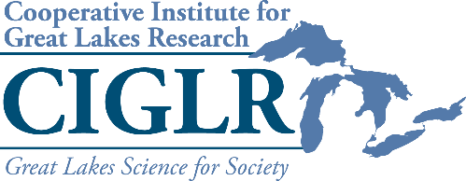
2022 Rapid Funding
Request for Proposals

The Cooperative Institute for Great Lakes Research provides short-term funding up to $10,000 to form an initial response to an emergency or time-sensitive need in the Great Lakes (e.g., Flint water crisis, Toledo water crisis, oil or chemical spill, 100-year storm, etc.). Rapid funds provide the seed funding researchers need to be ‘first-responders’ even as they solicit more substantial funds from an appropriate agency or organization. Any principal investigator or student from a Regional Consortium University Partner institution or Private Sector Partner organization may request rapid funding.
Rapid proposals begin with a phone call to the CIGLR Director. If the Director approves, the applicant must submit a description of work that includes the following (1 page max):
- The problem or need.
- The response plan.
- The plan for securing additional funding to more fully address the issue.
- A general description of how the funds will be used.
Proposals will be judged on the: 1) urgency of the problem or issue, 2) potential of the proposed response to address the problem, and 3) likelihood of acquiring additional leveraged funds to more fully address the issue. Rapid fund proposals will be reviewed by CIGLR leadership (Director, Program Manager) and decisions will be made within 2 days. Rapid funds will be issued as a subaward from the University of Michigan to the recipient institution or organization; this process may take 30-60 days. CIGLR will provide an award letter that can be used to justify and request pre-award spending.
Recipients of rapid funds are required to submit a final report to CIGLR within 60 days of the completion of the response effort.
Rapid fund proposals may be submitted at any time. There is no deadline for this opportunity.
Contact CIGLR Director Greg Dick (gdick@umich.edu, 734-763-3228) with initial rapid fund requests or questions. Submit proposals to Mary Ogdahl, CIGLR Program Manager: ogdahlm@umich.edu.

