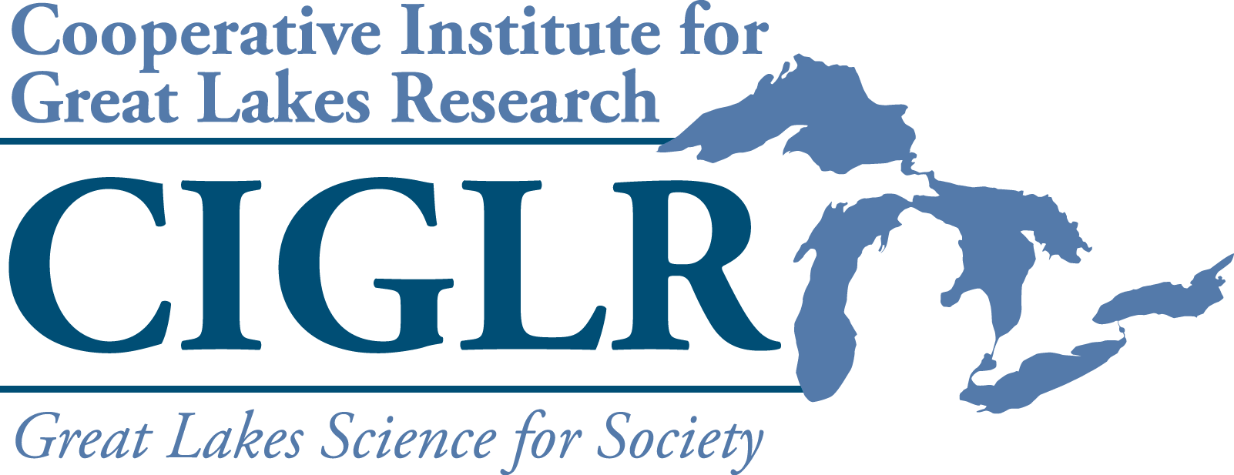Postdoctoral Fellowships

# 2025 Request for Proposals

Description. The Cooperative Institute for Great Lakes Research (CIGLR) is soliciting proposals from Regional Consortium partners for up to three (3) **CIGLR Postdoctoral Fellowships.** The goals of the Postdoctoral Fellowship Program are to 1) expand research training opportunities for postdoctoral scientists working in the area of freshwater sustainability, and 2) enhance collaborations between CIGLR’s Consortium partners and PIs at NOAA GLERL in ways that complement NOAA’s mission to improve research effectiveness and impact in the Great Lakes. We seek to use these fellowships to increase diversity in STEM disciplines (science, technology, engineering and math), and thus, strongly encourage proposals that support students from groups which have been traditionally underrepresented in government and academic workforces.

Funding. $90,000 is available for each 12-month Postdoctoral Fellowship. We will also consider proposals for fellowships covering a period of up to two years, for total funding up to $180,000.

Eligibility. Postdoctoral Fellowships may be used to support any postdoctoral scholar working with a mentor affiliated with a CIGLR Consortium institution or organization. Proposals may be submitted by either the postdoctoral scholar or mentor.

Requirements.

* Proposals should address at least one of CIGLR’s research themes in the Great Lakes. Please visit the [CIGLR website](https://ciglr.seas.umich.edu/research-themes/) for research theme descriptions.
* Proposals should demonstrate direct involvement with both a Consortium lead mentor and a [NOAA Great](https://www.glerl.noaa.gov/res/Profiles/) [Lakes Environmental Research Laboratory (GLERL)](https://www.glerl.noaa.gov/res/Profiles/) or [CIGLR Research Institute](https://ciglr.seas.umich.edu/research-institute-staff/) co-mentor.
* Fellowship recipients are required to attend CIGLR’s next All Partners Meeting (TBD) to give a poster on their work, and to submit a final report to CIGLR at completion of the fellowship.

Application Process. Applications consist of an online form where you will be asked to enter the following:

## Identifying information

Proposal title, desired start/end dates, student information (name, affiliation, degree program and year, email), mentor/co-mentor information (names, affiliations, emails)

## Optional biographic information

CIGLR strives to increase diversity in STEM disciplines through this fellowship program. We invite you to provide demographic information that will help us track our efforts to increase the application rate of students from underrepresented groups. Answers to all of the biographic questions are optional.

1. **Proposal file upload.** Please prepare a single PDF using the attached template, which includes the following sections:
   1. Main body (4 pages max)
      1. Introduction: Provide background information on the research topic, ending with the research question(s) to be addressed.
      2. Hypothesis(es): State testable hypotheses and the corresponding predictions for those hypotheses. Explain the corresponding rationale for the hypotheses and predictions. Proposals lacking testable hypotheses and clear predictions will not be funded.
      3. Methods: Describe the study approach(es) and general methodologies to be used in sufficient detail that they can be evaluated by a general expert.
      4. Significance: The main body of the proposal should end with a section describing the anticipated results, their relevance to CIGLR’s research themes, and their importance to society.
   2. Postdoctoral mentoring plan (1 page)
      1. Co-mentoring plan: Identify the Consortium lead mentor and a NOAA-GLERL or CIGLR Research Institute co-mentor. Describe plans to ensure active collaboration between the fellow, mentor, and the GLERL or CIGLR co-mentor. Applicants **must** contact the potential GLERL or CIGLR co-mentor(s) to discuss proposed research before applying. For assistance identifying an appropriate CIGLR or GLERL co-mentor, please send a brief description of your research topic to Mary Ogdahl, CIGLR Managing Director ([ogdahlm@umich.edu](mailto:ogdahlm@umich.edu)).
      2. Postdoctoral training: Describe plans to provide the postdoc with professional training that includes career counseling, experience writing proposals, mentoring on publications and presentations, experience in reviewing papers and proposals, development of teaching and mentoring skills, and experience in broader impacts like public outreach and communication.
   3. Budget (1 page)

Submissions should provide a budget and corresponding budget justification. The budget should total $90,000 for 12 months or $180,000 for 24 months. Universities must abide by the budget terms outlined in their MOUs with CIGLR to receive these fellowships, which specify a reduced indirect cost rate of 10%. Any matching funds should also be highlighted in the budget and justification. Non-sponsored matching funds are encouraged, but not required.

## 5. CV or Resume upload

Please upload the fellowship candidate’s resume or curriculum vitae.

Review process. Proposals will be reviewed and ranked by the CIGLR Director and members of the CIGLR Council of Fellows (not collaborating on submitted proposals) for final award selection. Proposals will be judged on: 1) the quality of the science, 2) potential for the research to make a societal impact, 3) consistency with CIGLR and NOAA GLERL’s research mission and themes, 4) potential to foster **new** interactions between NOAA GLERL / CIGLR and the CIGLR Regional Consortium, and 5) the quality of the postdoc mentoring plan and the level of commitment to the dual mentorship.

Proposal submission. **Please submit your proposals via** [**this form**](https://umich.qualtrics.com/jfe/form/SV_37AKbpWi7syyEaa) **by 5 pm ET on January 31, 2025.** You may direct inquiries to Mary Ogdahl ([ogdahlm@umich.edu](mailto:ogdahlm@umich.edu)), CIGLR Managing Director.

CIGLR will announce **final decisions by March 3, 2025**. Funding for the fellowships will be sub-awarded by the University of Michigan to the institution or organization of the selected Consortium mentor.

# 2025 CIGLR Postdoctoral Fellowship Proposal

1. **INTRODUCTION**
2. **HYPOTHESES**
3. **METHODS**
4. **SIGNIFICANCE**
5. **CO-MENTORING PLAN**
6. **POSTDOCTORAL TRAINING**
7. **BUDGET with JUSTIFICATION**