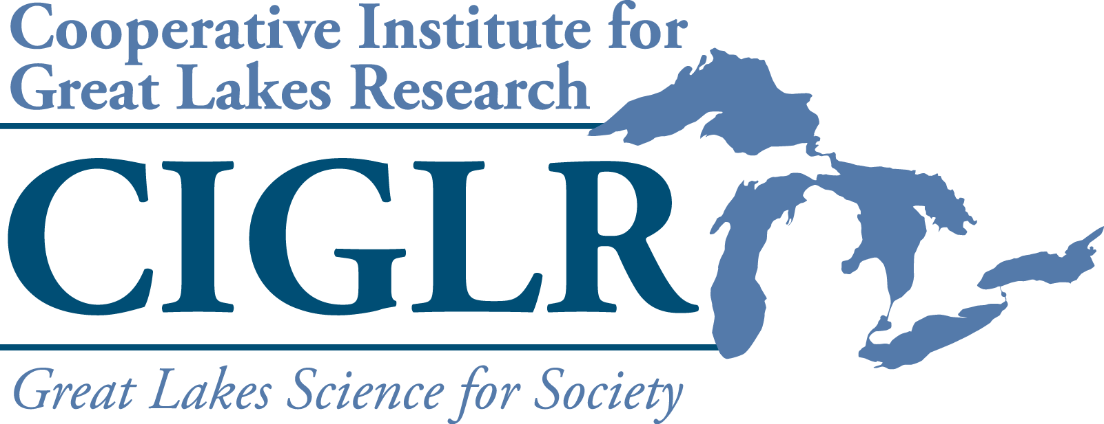2025 Great Lakes Summer Fellows Program

**Request for Position Proposals**

The Cooperative Institute for Great Lakes Research administers an annual Great Lakes Summer Fellows Program sponsored by NOAA’s Great Lakes Environmental Research Laboratory (GLERL). This competitive program places promising upper-level undergraduate and graduate students with both academic and federal government mentors to work on substantive research issues in the Great Lakes. Through this program, we seek to develop a diverse new generation of Great Lakes scientists by valuing a wide range of identities, qualities, experiences, and skills that bring important perspectives to solving current and future Great Lakes challenges.

We will offer a minimum of six (6) summer fellowships during 2025, with the potential for additional fellowships supported by mentor-contributed funds. Contributing to the pool of 6 fellowships allows mentors to take advantage of a highly competitive national search, a program focused on diversity, the flexibility to bring a

pre-identified candidate into the program, and access to CIGLR’s career training program and alumni network.

Position proposals should include a statement indicating whether the project is eligible for a fully remote, hybrid, or fully in-person fellowship. Positions that are eligible for fully remote or hybrid work should be designed to be performed without access to the GLERL network or GLERL high performance computers. We strongly encourage you to consider offering a hybrid or fully remote experience to increase accessibility to the program.

We highly recommend that your proposed projects are scalable to accommodate students at different academic levels and with a range of backgrounds and skills.

Eligibility: Prospective mentors from the CIGLR Research Institute, the CIGLR Regional Consortium, and NOAA (based at GLERL) are invited to submit fellowship position proposals. Fellowship position proposals from Regional Consortium members must include co-mentorship by a NOAA or CIGLR Research Institute collaborator; Regional Consortium applicants are encouraged to contact potential GLERL or CIGLR co-mentors to discuss proposed research before applying. Staff members proposing to mentor or co-mentor a summer fellow should seek approval from their supervisor prior to submitting an application.

Proposal Process.

Applications consist of an online form where you will be asked to enter the following:

1. Project title
2. Mentor(s) name(s) and affiliation(s)
3. Background and rationale for the fellowship project (3-4 sentences)
4. The research question(s) to be addressed by the project (1-2 sentences)
5. The project activities of the fellowship (1-2 sentence statement + bulleted list of specific tasks)
6. Required skills (1-2 sentences). Please keep in mind that this fellowship is a training opportunity. Therefore, skills should be broadly applicable to a diverse set of candidates who may not have had prior access to project-specific experiences. We are no longer advertising desired skills, so please give careful consideration to what skills are truly needed for a student to successfully complete the project.
7. Mentorship plan that describes how active collaboration between the student and mentor(s) will be fostered. (1-2 sentences)
8. Funding source:
   1. Fellowship program funds - CIGLR has funding from NOAA GLERL to support 6 competitive positions.
   2. Mentor-contributed funds – Prospective mentors may propose projects for which they have an alternate source of funding, to add to the pool of 6 program-funded positions. The cost per fellow is $10,000 plus

1

an additional $1,500 travel allowance. If the funds reside within the CIGLR Research Institute, they are exempt from indirect costs. Positions funded in this way may or may not have a pre-identified candidate. If there is no pre-identified candidate, the position will be included in the national search.

1. Travel information: Indicate if the fellow will need to travel for field work and if so, whether you have project funds (beyond the fellowship stipend and relocation allowance) to support their travel costs.
2. Computing needs. Indicate if the fellow will require a laptop (a desktop will otherwise be provided), UM HPC access, or special software. GLERL IT may be consulted during proposal development by sending an email to [help.glerl@noaa.gov](mailto:help.glerl@noaa.gov).
3. Position location:
   1. Are you open to a remote or hybrid (i.e., some days in person, some days remote) fellowship?

If you answer no to this question, please include a justification for in-person only work, keeping in mind that this will limit accessibility and therefore diversity in your candidate pool.

* 1. Where will your position be housed for in-person work? This could be NOAA GLERL, Lake Michigan Field Station (LMFS), or a partner facility. NOAA GLERL or LMFS are preferred locations; however, proposals that include a strong justification and documented support from GLERL or CIGLR mentor for the fellowship to be conducted at partner facilities will be considered.

Proposals will be judged on: 1) consistency with CIGLR’s and NOAA GLERL’s research themes, 2) scientific merit of the proposed project, 3) feasibility of accomplishing the stated objectives during the 12-week fellowship period,

4) scalability of the proposed project to accommodate a range of student skill levels, 5) significance of the student training opportunity, 6) potential for the project to improve participation in Great Lakes research and STEM training for historically underrepresented groups, and 7) potential to foster interaction between NOAA GLERL, the CIGLR Regional Consortium, and other key partners. Visit the [CIGLR website](https://ciglr.seas.umich.edu/organization/) for more information.

**Proposals should be submitted via** [**this form**](https://docs.google.com/forms/d/e/1FAIpQLSftoY_J08wvSDsUWq-K8HxcVTnEwtk84pwT_GAPg-hCOWUKPQ/viewform?usp=sf_link) **by 5 pm ET by November 29, 2024. Direct any questions to Margaret Throckmorton,** [**throckmj@umich.edu**](mailto:throckmj@umich.edu)**.**

Proposals will be reviewed by a committee composed of CIGLR leadership (Director, Managing Director) and CIGLR and GLERL PIs not collaborating on submitted proposals. CIGLR will announce the **final position decisions by December 13, 2024** and begin advertising the program to students in January 2025. Fellows will be selected by the end of March 2025. The program will run from May 27 through August 15.