**2025 Graduate Research Fellowships   
 Request for Proposals**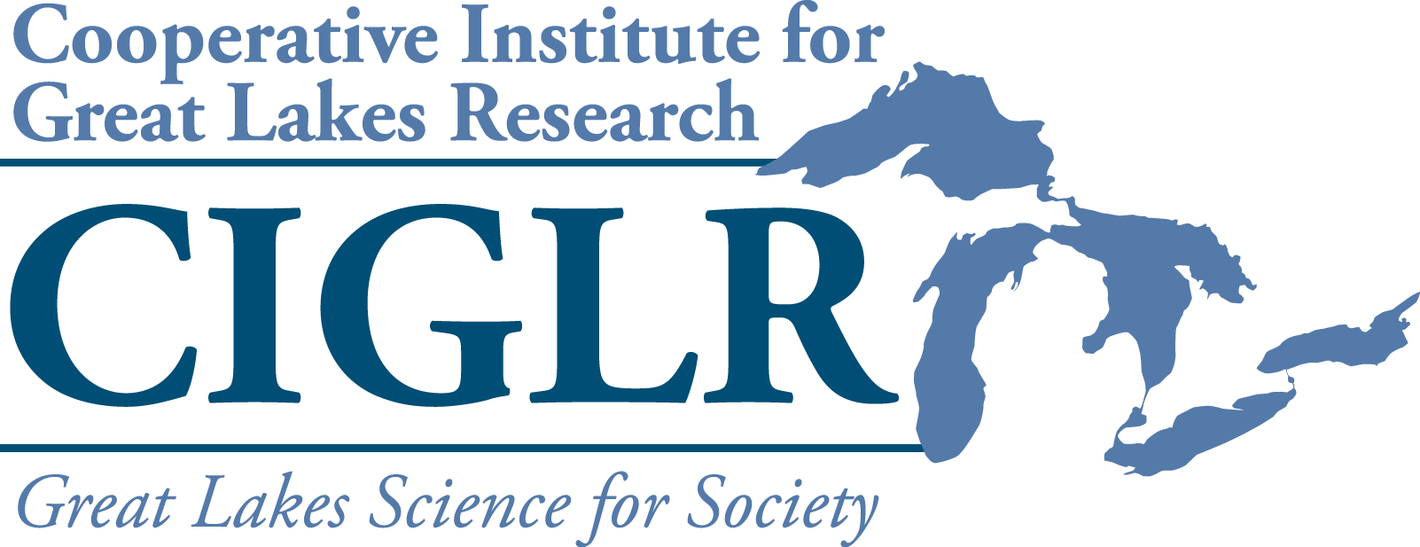

Description. The Cooperative Institute for Great Lakes Research (CIGLR) is soliciting proposals from Regional Consortium universities for three (3) **Graduate Research Fellowships** sponsoredbyNOAA’s Great Lakes Environmental Research Lab (GLERL) and the University of Michigan.The goals of these fellowships are: 1) to provide training and educational opportunities for students who will become the next generation of Great Lakes researchers, 2) enhance collaborations between CIGLR Regional Consortium partners and PIs at NOAA GLERL, and 3) increase student retention within the freshwater sciences.

Funding. Graduate Research Fellowships will provide graduate students (MS or PhD) with $40,000 of funding for 12 months. These funds can be used for student salary, tuition, supplies, and travel. Priority will be given to projects that foster interaction within the [CIGLR Regional Consortium](https://ciglr.seas.umich.edu/opportunities/eco-funding/).

Eligibility. Graduate Research Fellowships may be used to support any graduate student working with a tenure-track faculty member from a CIGLR Regional Consortium university. Proposals may be submitted by either the graduate student or faculty member. Prior CIGLR fellowship awardees are eligible to re-apply for additional funds.

Requirements.

* Graduate Research Fellowships require direct involvement with both a university lead mentor and a [NOAA Great Lakes Environmental Research Laboratory (GLERL)](https://www.glerl.noaa.gov/res/Profiles/) or [CIGLR Research Institute](https://ciglr.seas.umich.edu/research-institute-staff/) co-mentor.
* There are two possible models for co-mentorship:
  1. The student spends the 9-mo. academic year at a CIGLR Regional Consortium institution/organization and the summer months at a NOAA facility, either GLERL in Ann Arbor, MI, or the Lake Michigan Field Station in Muskegon, MI.
  2. Twelve months at a CIGLR Regional Consortium institution/organization. Applicants choosing this model must demonstrate in their proposal a plan for regular interaction with the NOAA GLERL or CIGLR Research Institute co-mentor.
* Students who receive fellowships are required to attend CIGLR’s next All Partners Meeting (TBD) to give a poster on their work, and to submit a final report to CIGLR at completion of the fellowship.
* Projects must address at least one of [CIGLR’s research themes](https://ciglr.seas.umich.edu/research-themes/).

Application Process.

Applications consist of an online form where you will be asked to enter the following:

1. **Identifying information**

Proposal title, desired start/end dates, student information (name, affiliation, degree program and year, email), mentor/co-mentor information (names, affiliations, emails)

1. **Optional biographic information**

Answers to all the biographic questions are optional.

1. **Proposal file upload.** Please prepare a single PDF using the attached template, which includes the following sections:
   1. Main body (4 pages max)
      * Introduction: Provide background information on the research topic, ending with the research question(s) to be addressed.
      * Hypothesis(es): State testable hypotheses and the corresponding predictions for those hypotheses. Explain the corresponding rationale for the hypotheses and predictions. Proposals lacking testable hypotheses and clear predictions will not be funded.
      * Methods: Describe the study approach(es) and general methodologies to be used in sufficient detail that they can be evaluated by a general expert.
      * Significance: The main body of the proposal should end with a section describing the anticipated results, their relevance to CIGLR’s research themes, and their importance to society.
   2. Co-mentoring plan (0.5 to 1 page)

Identify the university lead mentor and a NOAA GLERL or CIGLR Research Institute co-mentor. Describe plans to ensure active collaboration between the fellow, faculty mentor, and the GLERL or CIGLR co-mentor. Applicants **must** contact potential GLERL or CIGLR co-mentors to discuss proposed research before applying. For assistance identifying an appropriate CIGLR or GLERL co-mentor, please send a brief description of your research topic to Mary Ogdahl, CIGLR Managing Director ([ogdahlm@umich.edu](mailto:ogdahlm@umich.edu)).

* 1. Budget (1 page)

Submissions should provide a budget and budget justification. The budget should total $40,000 for 12 months, and can include student salary, tuition, supplies, and travel. Universities must abide by the budget terms outlined in their MOUs with CIGLR to receive these fellowships, which specify a reduced indirect cost rate of 10%.

5. **CV or Resume upload**  
Please upload the fellowship candidate’s resume or curriculum vitae.

Review process. Proposals will be reviewed and ranked by the CIGLR Director and members of the CIGLR Council of Fellows (not collaborating on submitted proposals) for final award selection. Proposals will be judged on the: 1) quality of the science, 2) potential for the research to make a societal impact, 3) consistency with CIGLR and NOAA GLERL’s research mission and themes, 4) level of commitment to the dual mentorship of the student and student training, and 5) potential to foster **new** interactions between NOAA GLERL / CIGLR and the CIGLR Regional Consortium.

Proposal submission**. Proposals should be submitted via** [**this form**](https://umich.qualtrics.com/jfe/form/SV_37AKbpWi7syyEaa) **by 5 pm ET on January 31, 2025.** You may direct inquiries to Mary Ogdahl ([ogdahlm@umich.edu](mailto:ogdahlm@umich.edu)), CIGLR Managing Director.

CIGLR will announce the **final decisions by March 3, 2025**. Funding for the fellowships will be sub-awarded by the University of Michigan to the host universities of the selected faculty members.

**2025 CIGLR Graduate Research Fellowship Proposal**

1. **INTRODUCTION**
2. **HYPOTHESES**
3. **METHODS**
4. **SIGNIFICANCE**
5. **CO-MENTORING PLAN**
6. **BUDGET ($40,000) with JUSTIFICATION**